Lecture 4 Notes: Financial Statement Analysis – Part 1
Ratio, Trend, Common-Size, and Industry Comparison Analyses

Introduction
We have all seen financial wizards and computer geeks in the movies who can take a company’s financial statements apart in minutes, calculate a few ratios, compare to similar firms (or to the industry), and discover the company’s innermost secrets. The truth, however, is that such analyses are no substitute for a crystal ball. They are just a convenient way to summarize large quantities of financial data and to compare firms’ performances. While these analytical tools enable us to focus our attention in order to start asking the right questions, they seldom provide answers.

We will begin with ratio analysis, then use multiple years of ratios to conduct trend analysis. These two analyses will be conducted together. We will also discuss common-size analysis in order to compare firms of different sizes. Finally, we will compare the firm under review with the industry average (or median).

As with the previous set of lecture notes (Lecture 2A Notes), we will employ the Cox Oil Company, Inc. example to apply all the financial concepts and analyses mentioned above. Therefore, the financial statements for Cox Oil Company, Inc. follow:
Cox Oil Company, Inc.
Consolidated Balance Sheet
December 31
(Dollars in Thousands, Except Per-Share Amounts)

Assets 2007 2006
Current Assets:
Cash and cash equivalents $ 19,500 $ 15,000
Marketable securities 46,300 32,000
Accounts receivable (net) 156,000 145,000
Inventories 180,000 185,000
Prepaid expenses and other current assets 4,000 3,000
Total current assets 405,800 380,000
Long-Term Assets:
Gross property, plant and equipment 185,000 146,600
Less: accumulated depreciation 35,000 27,000
Net property, plant and equipment 150,000 119,600
Gross reserves 200,000 200,000
Less: accumulated depletion 90,000 70,000
Net reserves 110,000 130,000
Total long-term assets (net) 260,000 249,600
Other Assets:
Gross intangibles (goodwill, patents) 2,250 2,250
Less: accumulated amortization 300 250
Net intangibles 1,950 2,000
Investment securities (at cost) 300 -
Total other assets (net) 2,250 2,000
Total Assets $668,050 $631,600

Liabilities and Shareholders’ Equity 2007 2006
Liabilities:
Current Liabilities:
Accounts payable $ 60,000 $ 57,000
Notes payable 51,000 61,000
Accrued expenses 30,000 36,000
Income taxes payable 17,000 15,000
Other current liabilities 12,000 12,000
Current portion of long-term debt 6,000 -
Total current liabilities 176,000 181,000
Long-Term Liabilities:
Deferred income taxes 16,000 9,000
9.12% debenture payable 2010 130,000 130,000
Other long-term debt - 6,000
Total Liabilities 322,000 326,000

Shareholders’ Equity:
Preferred stock, $5.83 cumulative,
$100 par value; authorized, issued
and outstanding: 60,000 shares 6,000 6,000
Common stock, $5.00 par value,
authorized: 20,000,000 shares;
issued and outstanding:
2007 – 15,000,000 shares
2006 – 14,500,000 shares 75,000 72,500
Additional paid-in capital 20,000 13,500
Retained earnings 249,000 219,600
Foreign currency translation adjustment (net of tax) 1,000 (1,000)
Unrealized gain on available-for-sale securities (net of tax) 50 -
Less: Treasury stock at cost
(2007 and 2006 – 1,000 shares) (5,000) (5,000)
Total Shareholders’ Equity 346,050 305,600

Total Liabilities and Shareholders’ Equity $668,050 $631,600

Cox Oil Company, Inc.
Consolidated Income Statement
January 1 through December 31
(Dollars in Thousands, Except Per-Share Amounts)

2007 2006
Net sales $765,050 $725,000
Cost of goods sold 535,000 517,000
Gross Profit 230,050 208,000
Operating expenses:
Selling, general and administrative expenses 96,804 109,500
Depreciation, depletion and amortization 28,050 25,000
Earnings before interest and taxes (EBIT) 105,196 73,500
Interest Expense 16,250 16,750
Dividend and interest income 5,250 10,000
Earnings before taxes and extraordinary items 94,196 66,750
Income tax 41,446 26,250
Earnings before extraordinary items 52,750 40,500
Extraordinary item: Loss on earthquake
destruction (net of income tax benefit of $750) (5,000) -
Net income $ 47,750 $ 40,500

Earnings per share of common stock before
extraordinary item $ 3.55 $ 2.77
Earnings per share – extraordinary item (0.34) -
Net income per common share $ 3.21 $ 2.77

Cox Oil Company, Inc.
Consolidated Statement of Cash Flows
For Year Ended December 31, 2007
(Dollars in Thousands)

2007
Cash flows from operating activities:
Net income before dividends $ 47,750
Additions (Sources of Cash):
Depreciation, depletion, and amortization 28,050
Decrease in inventory 5,000
Increase in accounts payable 3,000
Increase in income taxes payable 2,000
Increase in deferred taxes 7,000
Subtractions (Uses of Cash):
Increase in accounts receivable (11,000)
Increase in prepaid expenses and other current assets (1,000)
Decrease in accrued expenses (6,000)
Net cash provided by operating activities $ 74,800

Cash flows from investing activities:
Securities purchases (14,600)
Principal payment received on securities 50
Long-term asset purchases (38,400)
Net cash used in investing activities $(52,950)

Cash flows from financing activities:
Decrease in notes payable $(10,000)
Increase in common stock 9,000
Payment of dividends (18,350)
Net cash used in financing activities $(19,350)

Effect of exchange rate changes on cash $ 2,000

Net increase in cash and cash equivalents $ 4,500
Cash and cash equivalents at beginning of the year 15,000

Cash and cash equivalents at end of the year $ 19,500

Ratio and Trend Analyses
As your textbook points out: “The primary goal of financial management is to maximize shareholders’ wealth over the long run, not to maximize accounting measures such as net income or EPS. However, accounting data influence stock prices, and these data can be used to understand why a company is performing the way it is and to forecast where it is heading.”

We will describe and calculate several different types of financial ratios including:

Liquidity Ratios measure how easily the company can lay its hands on cash;
Asset Management Ratios (also known as Efficiency or Turnover Ratios) measure how productive the firm is at utilizing its assets;
Debt Management Ratios (also known as Leverage Ratios) measure how heavily the company is in debt;
Profitability Ratios are used to measure the firm’s return on its investments; and
Cash Flow Ratios measure the coverage and quality of a firm’s cash flows.

For each ratio, we will include the following four items:

- How the ratio is calculated;
- An interpretation of the ratio;
- The calculation of the ratio for 2007 and 2006 for Cox Oil Company, Inc.; and
- An interpretation of the ratios and the trend for Cox Oil Company, Inc.

We will conclude this portion of the lecture notes with a framework for utilizing the various ratios we have calculated. This framework is known as Du Pont Analysis, in recognition of the chemical company that popularized the procedure.

Liquidity Ratios

Liquidity is a measure of the quality and adequacy of current assets to meet current obligations as they come due.

Current Ratio

Computation: Total current assets divided by total current liabilities.

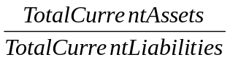

Interpretation: This ratio is a rough indication of a firm’s ability to service its current obligations. Generally, the higher the current ratio, the greater the ‘cushion’ between current obligations and a firm’s ability to pay them. The stronger ratio reflects a numerical superiority of current assets over current liabilities. However, the composition and quality of current assets is a critical factor in the analysis of an individual firm’s liquidity.

Cox Oil Company, Inc.:

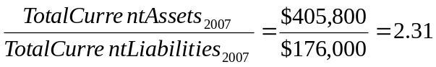

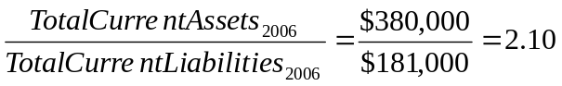

Interpretation of Cox: The current ratio for Cox for each year is greater than 1:1 indicating that theoretically Cox will be able to pay its current liabilities with its current assets. Further, the trend from 2006 to 2007 is increasing, indicating that Cox’s ‘cushion’ has increased.

Quick Ratio

Computation: Current assets minus inventory divided by total current liabilities.

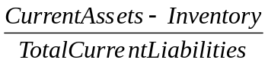

Interpretation: Also known as the ‘Acid Test’ ratio, it is a refinement of the current ratio and is a more conservative measure of liquidity. The ratio expresses the degree to which a company’s liabilities are covered by the most liquid current assets. Generally, any value of less than 1:1 implies a dependency on inventory to liquidate short-term debt. The ratio values should always be positive.

Cox Oil Company, Inc.:

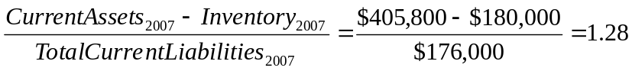

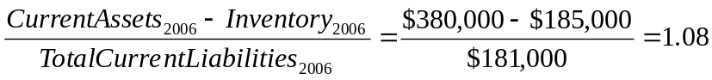

Interpretation of Cox: Cox’s quick ratio is above 1:1 for each year, indicating that Cox is not necessarily dependent on inventory to cover its current obligations. Further, Cox’s ratio is increasing, suggesting a positive trend.

Net Working Capital Turnover

Computation: Net sales divided by net working capital (current assets less current liabilities equals net working capital).

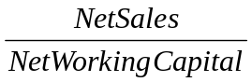

Interpretation: Net working capital is defined as current assets minus current liabilities. It provides a measure of the margin of protection for current creditors and reflects the ability to finance current operations. Comparing the level of sales arising from operations to the underlying working capital measures how efficiently working capital is employed. A low ratio may indicate an inefficient use of working capital while a very high ratio often signifies overtrading (vulnerable position for creditors). If working capital is negative, the quotient will be negative.

Cox Oil Company, Inc.:

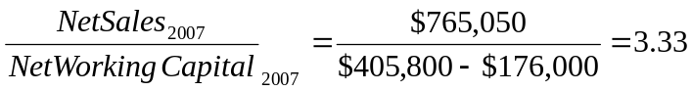

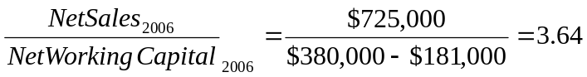

Interpretation of Cox: Cox’s net working capital turnover indicates that $3.33 ($3.64) of net sales is generated for every $1 of working capital in 2007 (2006). The trend from 2006 to 2007 is decreasing, which suggests a need for investigation to try to understand the reason for the decline.

Asset Management Ratios

Accounts Receivables Turnover

Computation: Net sales divided by net accounts receivables.

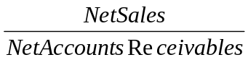

Interpretation: This ratio measures the number of times accounts receivables turn over during the year. The higher the turnover of receivables, the shorter the time between sale and cash collection. If a company’s receivables appear to be turning slower than the rest of the industry, further research is needed and the quality of the receivables should be examined closely. One important problem with this ratio is that it compares receivables on one day, shown at statement date, to total annual net sales and does not take into consideration seasonal fluctuations.

Cox Oil Company, Inc.:

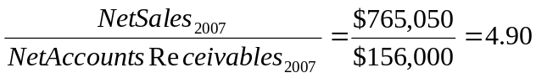

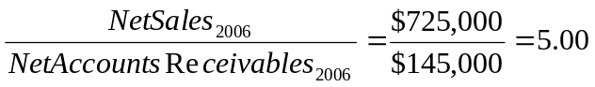

Interpretation of Cox: Cox’s accounts receivable turnover indicates that the company turned over its receivables 4.9 (5.0) times in 2007 (2006). The trend from 2006 to 2007 indicates that receivables turnover is slowing down, meaning that it is taking Cox longer in 2007 to collect its account receivables than it did in 2006. The reason for this slowdown should be investigated since additional cash is being tied up in Cox’s receivables.

Days’ Receivable (or Days Sales Outstanding)

Computation: The receivables turnover ratio divided into 365 (the number of days in one year).

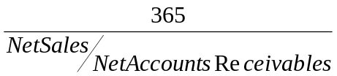 or 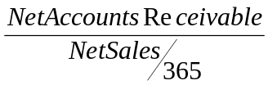 (our textbook)

Interpretation: This figure expresses the average time in days that receivables are outstanding. Generally, the greater number of days outstanding, the greater the probability of delinquencies in accounts receivables. A comparison of a company’s daily receivables may indicate the extent of a company’s control over credit and collections. The terms offered by a company to its customers, however, may differ from terms within the industry and should be taken into consideration.

Cox Oil Company, Inc.:

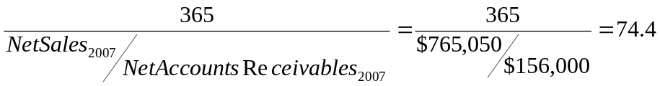

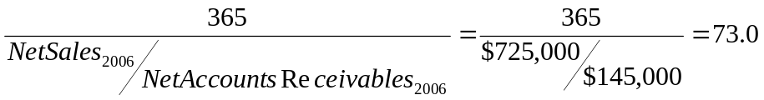

Interpretation of Cox: In 2007, it took Cox 74.4 days to collect its accounts receivable. This is an increase from the 73 days the firm took to collect receivables in 2006. Again, this slowdown in collection, while small, should be investigated, as it is a negative trend.

Inventory Turnover

Computation: Cost of goods sold divided by inventory.

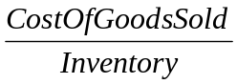

Interpretation: This ratio measures the number of times inventory is turned over during the year. High inventory turnover can indicate better liquidity or superior merchandising. Conversely, it can indicate a shortage of needed inventory for sales. Low inventory turnover can indicate poor liquidity, possible overstocking, obsolescence, or in contrast to these negative interpretations a planned inventory buildup in the case of material shortages. A problem with this ratio is that it compares inventory at a point in time to annual cost of goods sold and does not take seasonal fluctuations into account.
Note: Some textbooks, including the one we are using in this course, use net sales rather than cost of goods sold to calculate the inventory turnover ratio. That is, they use the following ratio: 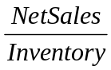. The problem with using this alternate form of the inventory turnover ratio is that inventory is a cost and net sales, hopefully, represents a profit over costs. Therefore, this alternate ratio mixes costs with cost plus a return. The more proper format, i.e., the one using cost of goods sold in the numerator of the ratio, employs items at cost in both numerator and denominator of the ratio. While using cost of goods sold is the more desirable method to calculate this ratio, it is important to understand what ratio the Industry Average Benchmark uses (as well as what textbook uses – in your case the textbook uses sales rather than cost of goods sold). For example, RMA Annual Statement Studies uses cost of goods sold as the numerator, while Standard & Poor’s (S&P) uses net sales as the numerator. While RMA is theoretically correct, and S&P is not, it is more important to calculate the ratio in the same fashion as the Industry Average Benchmark you plan to compare it to! We will be using RMA as the industry benchmark.

Cox Oil Company, Inc.:

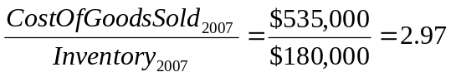; 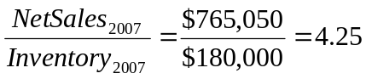

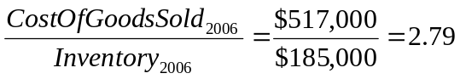; 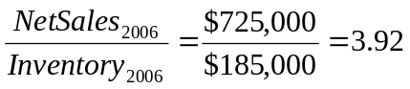

Interpretation of Cox: Cox turned over its inventory 2.97 times (2.79 times) in 2007 (2006). This represents an increase in turnover, which is a positive trend. The trend using net sales is the same.

Days' Inventory

Computation: Inventory turnover ratio divided into 365 (the number of days in one year).

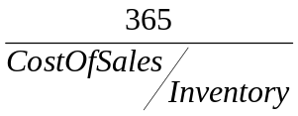

Interpretation: Division of the inventory turnover ratio into 365 days yields the average length of time units are in inventory.

Cox Oil Company, Inc.:

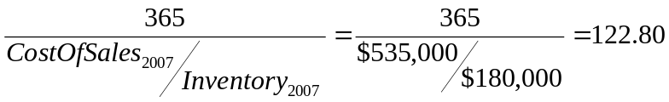

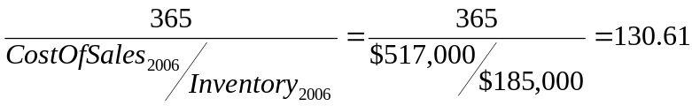

Interpretation of Cox: Cox’s inventory sat on the shelf for an average of 122.8 days in 2007 before it was sold, an improvement from the 130.61 days that inventory remained on the shelf in 2006.

Fixed Asset Turnover

Computation: Net sales divided by net fixed assets (net of accumulated depreciation).

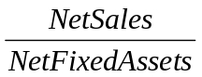

Interpretation: This ratio is a measure of the productive use of a firm’s fixed assets. Largely depreciated fixed assets or a labor intensive operation may cause a distortion of this ratio. This ratio cannot be calculated if fixed assets are zero and the ratio values should not be negative.
Note: The calculation of this ratio depends on the definition of Fixed Assets. If, by fixed assets, we mean PP&E, then we would use Net PP&E in the denominator. If, however, we mean Net Total Long-Term Assets, we would use Net Total Long-Term Assets in the denominator. The decision regarding which ratio to use is dependent on the ratio the Industry Average Benchmark uses.

Cox Oil Company, Inc.:

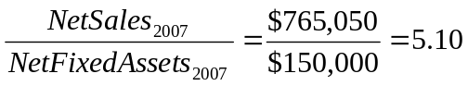 or 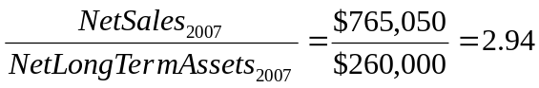

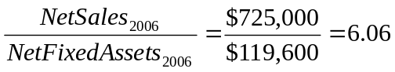 or 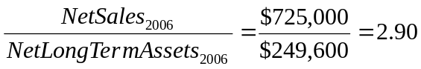

Interpretation of Cox: The interpretation of Cox’s ratio depends on which ratio you use! Using only Net PP&E, Cox generated $5.10 in sales for each $1 in Net PP&E in 2007, a decline from the $6.06 in sales generated for each $1 in Net PP&E in 2006. This indicates a negative trend! However, using Net Total Long-Term Asset (i.e., including Net Reserves with Net PP&E), Cox generated $2.94 in sales for each $1 in Net Total Long-Term Assets in 2007, an increase in the $2.90 in sales generated for each $1 in Net Total Long-Term Assets in 2006. This is a positive trend!!

Total Asset Turnover

Computation: Net sales divided by total assets.
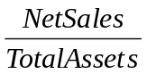

Interpretation: This ratio is a general measure of a firm’s ability to generate sales in relation to total assets. It should be used only to compare firms within specific industry groups and in conjunction with other ratios to determine the effective employment of assets.

Cox Oil Company, Inc.:

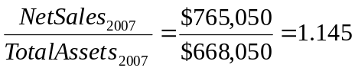

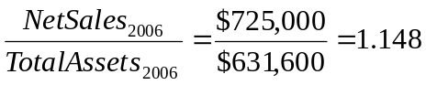

Interpretation of Cox: In 2007 Cox generated $1.145 in sales for each $1 invested in total assets, which is slightly lower than the $1.148 in sales for each $1 in total assets in 2006.

Debt Management Ratios

Payables Turnover

Computation: Cost of sales divided by trade payables.

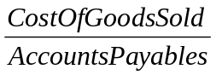

Interpretation: This ratio measures the number of times accounts payables turn over during the year. The higher the turnover, the shorter the time between purchases from a vendor and payments to a vendor. If a company’s payables appear to be turning more slowly than the industry, then the company may be experiencing cash shortages, disputing invoices with suppliers, enjoying extended terms, or deliberately expanding its trade credit. One notable problem with this ratio is that it compares payables at a point in time to annual cost of goods sold and does not take seasonal fluctuations into account.
Note: Some Industry Average Benchmarks may use net sales in the numerator.

Cox Oil Company, Inc.:

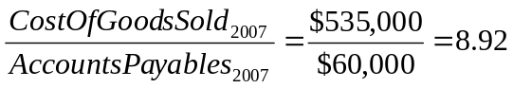; 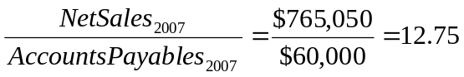

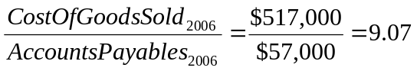; 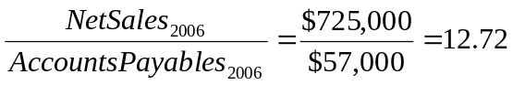

Interpretation of Cox: Cox turned over its accounts payable 8.92 times in 2007 compared to 9.07 times in 2006. The slowdown in accounts payable turnover means that Cox enjoyed longer trade terms from its vendors. This may be good if Cox’s vendors extended longer trade terms, or it may be negative if Cox simply is ‘stretching’ its accounts payable! The trend is the same if net sales are used.

Days’ Payables

Computation: The payables turnover ratio divided into 365 (the number of days in one year).

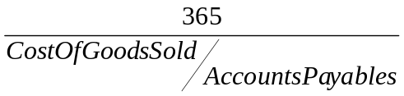

Interpretation: Division of the payables turnover ratio into 365 days yields the average length of time trade debt is outstanding.

Cox Oil Company, Inc.:

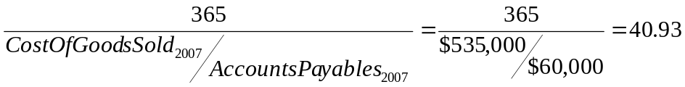

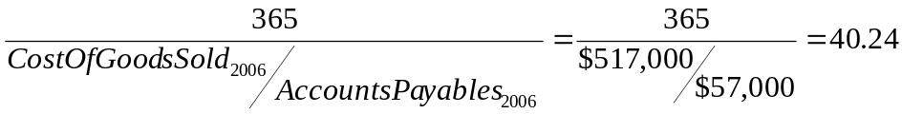

Interpretation of Cox: Cox paid its vendors after 40.93 days in 2007, a slight increase from the 40.24 days in 2006.

Debt to Total Assets

Computation: Total debt divided by total assets.

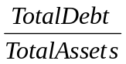

Interpretation: This ratio expresses the relationship between capital contributed by creditors and total assets (financed by creditors and contributed by owners). It states the percent of assets financed by debt. Looking at it another way, the ratio states the amount of debt to each dollar of assets.

Cox Oil Company, Inc.:

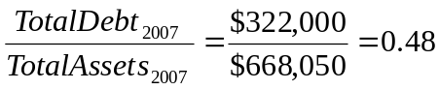

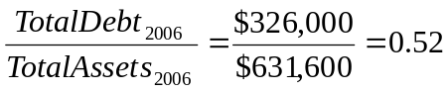

Interpretation of Cox: Each $1 in total asset in 2007 was financed by $0.48 of debt, a decrease from $0.52 of debt for each $1 in total assets in 2006. Cox de-levered its capital structure from 2006 to 2007, a positive trend since it represents a decrease in financial leverage. However, it will be important to compare these ratios with those of the industry average.

Times Interest Earned (TIE)

Computation: Earnings (profit) before annual interest expense and taxes divided by annual interest expense.

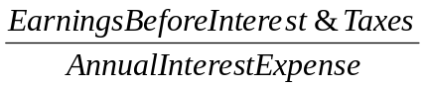

Interpretation: This ratio is a measure of a firm’s ability to meet interest payments. A high ratio may indicate that a company would have little difficulty in meeting the interest obligations of loans. This ratio also serves as an indicator of a firm’s capacity to take on additional debt.

Cox Oil Company, Inc.:

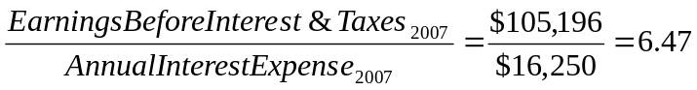

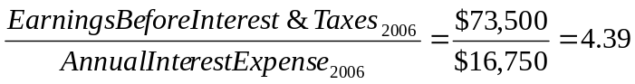

Interpretation of Cox: Cox’s TIE ratio was 6.47 times in 2007, a significant improvement from 4.39 times in 2006. This represents a positive trend.

Profitability Ratios

Net Profit Margin

Computation: The net profit margin on sales is computed by dividing net income after taxes by net sales.

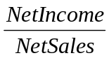

Interpretation: This ratio indicates the profit per dollar of sales.

Cox Oil Company, Inc.:

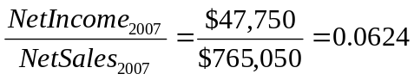

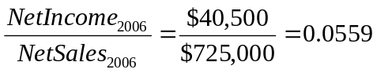

Interpretation of Cox: Cox’s net profit margin for 2007 was 6.24%, indicating that out of each $1 of net sales, Cox gets to keep 6.24 cents. This represents an improvement from the 5.59% in 2006.

Return On Assets (ROA)

Computation: The ratio of net income to total assets.

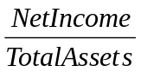

Interpretation: This ratio measures the rate of return (after interest and taxes) on total assets. The ratio is useful for comparing prior year’s rate of return with the current year’s rate of return; however, it is not particularly useful when making inter-firm comparisons because it is sensitive to differences in capital structure.

Cox Oil Company, Inc.:

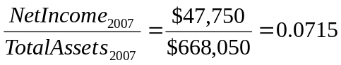

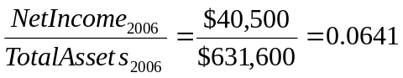

Interpretation of Cox: Cox’s return on assets was 7.15% in 2007, an improvement from 6.41% in 2006.

Return On Equity (ROE)

Computation: The ratio of net income to common equity.

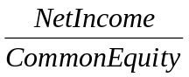

Interpretation: This ratio measures the rate of return on the common stockholders’ investment. The ratio is useful for both intra-company and inter-firm comparisons.

Cox Oil Company, Inc.:

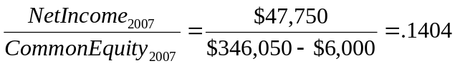

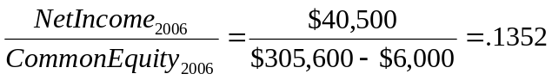

Interpretation of Cox: Cox’s return on common equity in 2007 was 14.04%, an improvement from the 13.52% return on common equity in 2006.

Cash Flow Ratios

Cash Flow Coverage of Interest Expenses

Computation: Cash flow from operating activities plus interest expense divided by interest expense.



Interpretation: This ratio is similar to the Times Interest Earned ratio; however, in this case the ratio measures the firm’s ability to meet interest payments from cash flow. This ratio is a more realistic measure than Times Interest Earned.

Cox Oil Company, Inc.:

Interpretation of Cox: Cox’s cash flow coverage of interest expenses in 2007 was 5.6 times. There is not enough information to calculate Cox’s cash flow from operating activities in 2006.

Quality of Earnings

Computation: Cash flow from operating activities minus preferred dividends divided by earnings available for common stockholders.

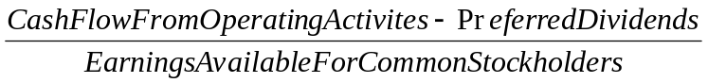

Interpretation: This ratio shows the amount of cash flow dollars available to common stockholders for each dollar of net income after preferred dividend. A number greater than one indicates strength in the form of company cash flow.

Cox Oil Company, Inc.:

Interpretation of Cox: Cox generated $1.57 in cash flow available to common shareholders for each $1 of net income available to common shareholders. There is not enough information to calculate Cox cash flow from operating activities in 2006.

Du Pont Analysis

Despite the differences between accounting and finance, a firm’s published financial statements (or pro forma statements) can often offer some clues about its financial condition and insights into its past (or expected) performance. In analyzing a firm’s performance using its financial (historic or pro forma) statements, it is helpful to define a set of ratios, and a framework, to facilitate comparisons over time and across companies. A framework often used for this purpose is Du Pont Analysis.

Du Pont Analysis is so called because Du Pont’s managers developed the general approach, demonstrating the relationships between profit margin (i.e., expense control), asset turnover (i.e., asset utilization), and financial leverage. Each of these three is briefly discussed below.

First, we will examine profitability ratios, which assess the firm’s ability to control expenses. Profitability can be measured with respect to sales (e.g., return on sales), assets (e.g., return on assets), or the equity base (e.g., return on equity). For Du Pont Analysis, the profit margin or return on sales is used. The broad measure used in Du Pont is net profit margin, or net income divided by net sales. However, in order to be comparable with many industry benchmarks (e.g., RMA’s Annual Statement Studies) income is taken as earnings before interest and taxes (EBIT) to avoid differences in capital structure and taxability (for example, partnerships, LLCs, and S-Corps, which are pass-through business organizational forms where the business entity does not pay taxes). Gross profit margin (gross profit divided by net sales) and net operating profit margin (EBIT divided by net sales) are specific measures used to determine how well management is controlling cost of goods sold expenditures and operating expenditures.

Second are asset turnover ratios, which assess the firm’s ability to use its assets productively in generating revenue. Asset turnover, as a broad measure used in Du Pont Analysis, is total asset turnover (net sales divided by total assets), whereas receivables turnover, inventory turnover, fixed asset turnover, etc. are specific measures for these particular asset categories.

Finally, financial leverage ratios highlight the capital structure of the company, and the extent to which it is burdened with debt and preferred stock. Du Pont Analysis employs the leverage multiplier (total assets divided by common equity), which is also called the equity multiplier. Debt ratio measures and the times interest earned (or cash flow coverage) ratio indicate the ability of the firm to cover its interest payments.

Du Pont Analysis permits a useful decomposition of the company’s ROE, return on equity, into the product of two ratios: (1) ROA or the return on assets, and (2) LM or the leverage multiplier (or equity multiplier). The ratio decomposition that follows is the one that is typically used for trend analysis (i.e., internal use). It uses net income (as opposed to EBIT).

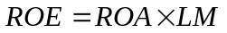
Or
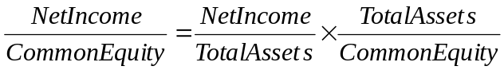

Notice that the denominator of ROA is the same as the numerator of LM. Therefore, they mathematically cancel each other out and we are left with net income divided by common equity, which is ROE or return on equity.

The ratio decomposition that follows is the one that is typically used for industry comparison analysis (i.e., external comparison purposes). It uses EBIT rather than net income.

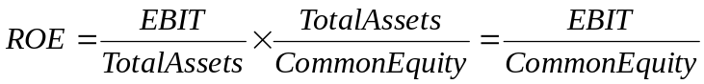

As with the equation above using net income, the two ratios in this decomposition are (1) return on assets and (2) the leverage (or equity) multiplier, respectively.

Further, ROA, return on assets, can be decomposed into net profit margin (net income divided by net sales or EBIT divided by net sales) and total asset turnover (sales divided by total assets) as follows:

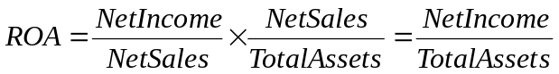

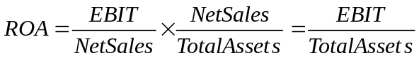

Again, notice that the denominator in the profit margin ratio and the numerator in total asset turnover ratio are the same, net sales. So, they cancel each other out mathematically and we are left with ROA.

Therefore, Du Pont Analysis enables us to focus on three factors that make up return on equity (ROE) consisting of profitability (or expense control), asset utilization, and financial leverage as follows:

Or
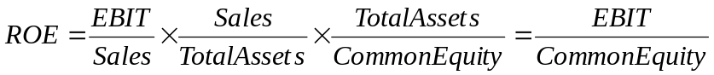

These three broad areas of focus enable us to conduct trend analysis and industry comparison analysis in order to determine potential problem areas. Once a potential problem area is determined, further analysis can be conducted to narrow down the probable cause within that area. An outline follows:

Area: Expense Control Asset Utilization Financial Leverage

Major Ratio: Profit Margin Total Asset Turnover Leverage Multiplier

Minor Ratios: Gross Profit Margin Receivables Turnover
Net Operating Profit Margin Inventory Turnover

Fixed Asset Turnover

Under the expense control category, the profit margin (net income divided by net sales or EBIT divided by net sales) provides a summary profitability measure for trend or industry comparison analysis (respectively). However, changes over time or unique attributes within industry do not permit us to determine precisely where or why these differences exist. Viewing the gross profit margin (net sales minus cost of goods sold divided by net sales) enable us to compare how well the firm’s management is controlling its cost of goods sold. Similarly, net operating profit margin (net sales minus cost of goods sold minus operating expenses divided by net sales), in conjunction with the gross profit margin, enable us to determine how well the firm is controlling its operating expenses or sales, general, and administrative (SG&A) expenses.

Under the asset utilization category, total asset turnover (net sales divided by total assets) also provides a summary measure, in this case of how well the firm’s management employs its assets. Again, changes over time and unique attributes within industry do not permit the precise determination of where or why these differences exist. Viewing turnover of each specific asset category (e.g., accounts receivable, inventory, fixed assets, etc.) enable us to more precisely focus in on potential problem areas.

Using the leverage (or equity) multiplier in the financial leverage category, and the accounting identity that assets equal liabilities plus equity, we can determine a general understanding about the firm’s capital structure. For example, if the leverage (or equity) multiplier is 1.65X, then we know that for every $1.65 in total assets there is $1 in equity financing and $0.65 in debt financing.

We can construct the Du Pont framework in chart form to make it easier to view:

ROE

ROA x LM

NPM x TAT

GPM Inv Turns
NOPM A/R Turns
FAT

We can also use the above chart form to layout and view trend analysis by simply posting the various ratios for multiple years. Below is the trend for Cox Oil Company, Inc.:

ROE
2007 2006
14.04% 13.52%

ROA x LM
2007 2006 2007 2006
7.15% 6.41% 1.964X 2.109X

NPM x TAT
2007 2006 2007 2006
6.24% 5.59% 1.145X 1.148X

GPM Inv Turns
30.07% 28.69% 2.97X 2.79X

NOPM A/R Turns
13.75% 10.14% 4.90X 5.00X

FAT
5.10X 6.06X

TLTAT
2.94X 2.90X

Expense Control Analysis
Reviewing the data in this form, we can see Cox’s management appears to be controlling expenses better in 2007, with a net profit margin of 6.24%, than they did in 2006, with a net profit margin of 5.59%. Gross profit margin is higher in 2007 than 2006 indicating management did a better job of controlling direct expenses (i.e., direct labor, direct material, and factory overhead). Cox’s management also was able to control operating expenses better in 2007 than in 2006. To see this, we need to look at both gross profit margins and net operating profit margins. The difference in the net operating profit margin of 3.61% between 2007 and 2006 (i.e., 13.75% - 10.14% = 3.61%) is greater than the difference in gross profit margin of 1.38% between 2007 and 2006 (i.e., 30.07% - 28.69%). This indicates Cox’s management is controlling both direct expenditures and indirect expenditures.

Asset Utilization Analysis
Total asset turnover slipped slightly from 1.148X in 2006 to 1.145X in 2007. It appears the two asset categories we should focus our time and attention on (i.e., ask questions to determine root cause of potential problems) are accounts receivable and fixed assets. Accounts receivable turnover declined from 5X in 2006 to 4.9X in 2007, and fixed asset turnover declined from 6.06X in 2006 to 5.1X in 2007.

Return on Assets (ROA)
Due primarily to Cox management’s expense control, return on assets improved from 6.41% in 2006 to 7.15% in 2007.

Leverage Analysis
Cox’s leverage (or equity) multiplier declined from 2.109X in 2006 to 1.964X in 2007. This indicates Cox’s management decreased the company’s use of debt from 2006 to 2007, which is generally considered a good trend. Financial leverage, i.e., the use of debt and preferred stock in the capital structure can be viewed as a double-edged sword. On the one hand, higher financial leverage exposes the firm to risk (i.e., the risk of not being able to meet its obligations on debt). On the other hand, higher financial leverage increases return to common shareholders. We can see this in the fact that if the leverage (or equity) multiplier increases, holding everything else constant, the return of equity increases!

Return on Equity (ROE)
Cox’s higher return on assets in 2007 than 2006, again primarily due to expense control, is responsible for the company’s higher return on equity of 14.04% in 2007 compared to 13.52% in 2006. Cox’s increase in return on assets more than offset the firm’s lower leverage (or equity) multiplier.

Comparative Analyses
There are two types of analysis that enable financial managers to make comparisons. The first is common-size analysis and the second is industry comparison analysis. We will discuss common-size analysis first and then industry comparison analysis.

Common-Size Analysis

Common-size analysis, a useful way of standardizing financial statements, expresses each item on the balance sheet as a percentage of total assets and expresses each item on the income statement as a percentage of net sales. The resulting financial statements are called common-size statements. In this form, financial statements are relatively easy to read and compare.

Below are the balance sheets and income statements for Cox for 2006 and 2007. To the right of each column of dollar amounts is the common-sized percentages.

Cox Oil Company, Inc.
Consolidated Balance Sheet
December 31
(Dollars in Thousands, Except Per-Share Amounts)

Assets 2007 % 2006 %
Current Assets:
Cash and cash equivalents $ 19,500 2.92% $ 15,000 2.37%
Marketable securities 46,300 6.93% 32,000 5.07%
Accounts receivable (net) 156,000 23.35% 145,000 22.96%
Inventories 180,000 26.94% 185,000 29.29%
Prepaid expenses and other current assets 4,000 0.60% 3,000 0.47%
Total current assets 405,800 60.74% 380,000 60.16%
Long-Term Assets:
Gross property, plant and equipment 185,000 27.69% 146,600 23.21%
Less: accumulated depreciation 35,000 5.24% 27,000 4.27%
Net property, plant and equipment 150,000 22.45% 119,600 18.94%
Gross reserves 200,000 29.94% 200,000 31.66%
Less: accumulated depletion 90,000 13.47% 70,000 11.08%
Net reserves 110,000 16.47% 130,000 20.58%
Total long-term assets (net) 260,000 38.92% 249,600 39.52%
Other Assets:
Gross intangibles (goodwill, patents) 2,250 0.34% 2,250 0.36%
Less: accumulated amortization 300 0.04% 250 0.04%
Net intangibles 1,950 0.30% 2,000 0.32%
Investment securities (at cost) 300 0.04% - 0.00%
Total other assets (net) 2,250 0.34% 2,000 0.32%
Total Assets $668,050 100.00% $631,600 100.00%

We could obtain the balance sheet for another publicly-traded oil company, common-size this other oil company’s assets from its balance sheet and make comparisons. For example, we can see that in 2007, Cox Oil Company, Inc. has 60.74% of its total assets in current assets, 38.92% in net long-term assets, and only 0.34% in other noncurrent assets. How would another oil company compare? If major differences existed in these major asset categories, we could compare the make up of each individual area in order to determine where differences arise.
Liabilities and Shareholders’ Equity 2007 % 2006 %
Liabilities:
Current Liabilities:
Accounts payable $ 60,000 8.98% $ 57,000 9.03%
Notes payable 51,000 7.63% 61,000 9.66%
Accrued expenses 30,000 4.49% 36,000 5.70%
Income taxes payable 17,000 2.55% 15,000 2.37%
Other current liabilities 12,000 1.80% 12,000 1.90%
Current portion of long-term debt 6,000 0.90% - 0.00%
Total current liabilities 176,000 26.35% 181,000 28.66%
Long-Term Liabilities:
Deferred income taxes 16,000 2.39% 9,000 1.43%
9.12% debenture payable 2010 130,000 19.46% 130,000 20.58%
Other long-term debt - 0.00% 6,000 0.95%
Total Liabilities 322,000 48.20% 326,000 51.62%

Shareholders’ Equity:
Preferred stock, $5.83 cumulative,
$100 par value; authorized, issued
and outstanding: 60,000 shares 6,000 0.90% 6,000 0.95%
Common stock, $5.00 par value,
authorized: 20,000,000 shares;
issued and outstanding:
2007 – 15,000,000 shares
2006 – 14,500,000 shares 75,000 11.23% 72,500 11.48%
Additional paid-in capital 20,000 2.99% 13,500 2.14%
Retained earnings 249,000 37.27% 219,600 34.77%
Foreign currency translation adjustment (net) 1,000 0.15% (1,000) (0.16%)
Unrealized gain available-for-sale securities (net) 50 0.01% - 0.00%
Less: Treasury stock at cost
(2007 and 2006 – 1,000 shares) (5,000) (0.75%) (5,000) (0.79%)
Total Shareholders’ Equity 346,050 51.80% 305,600 48.39%

Total Liabilities and Shareholders’ Equity $668,050 100.00% $631,600 100.00%

Again, we could obtain the balance sheet of another publicly-traded oil company, common-size it balance sheet, and make a comparison with Cox Oil Company, Inc. For 2007, Cox has 48.20% of its assets financed with liabilities (26.35% of assets financed with current liabilities and 21.85% of assets financed with long-term debt) and 51.80% of assets financed by equity. How would another oil company compare? If major differences existed in major categories, we could compare the make up of each individual area in order to determine where differences arise.
Cox Oil Company, Inc.
Consolidated Income Statement
January 1 through December 31
(Dollars in Thousands, Except Per-Share Amounts)

2007 % 2006 %
Net sales $765,050 100.00% $725,000 100.00%
Cost of goods sold 535,000 69.93% 517,000 71.31%
Gross Profit 230,050 30.07% 208,000 28.69%
Operating expenses:
Selling, general and administrative expenses 96,804 12.65% 109,500 15.10%
Depreciation, depletion and amortization 28,050 3.67% 25,000 3.45%
Earnings before interest and taxes (EBIT) 105,196 13.75% 73,500 10.14%
Interest Expense 16,250 2.12% 16,750 2.31%
Dividend and interest income 5,250 0.68% 10,000 1.38%
Earnings before taxes and extraordinary items 94,196 12.31% 66,750 9.21%
Income tax 41,446 5.42% 26,250 3.62%
Earnings before extraordinary items 52,750 6.89% 40,500 5.59%
Extraordinary item: Loss on earthquake
destruction (net of income tax benefit of $750) (5,000) (0.65%) - 0.00%
Net income $ 47,750 6.24% $ 40,500 5.59%

Earnings per share of common stock before
extraordinary item $ 3.55 $ 2.77
Earnings per share – extraordinary item (0.34) -
Net income per common share $ 3.21 $ 2.77

Once again, we could obtain the financial statement of another publicly-traded oil company, common-size its income statement, and compare its common-sized income statement with that of Cox Oil Company, Inc. For Cox in 2007, 69.93% of net sales went to cover direct costs (i.e., direct labor, direct material, and factory overhead), leaving 30.07% in gross profit margin. Further, 16.32% (i.e., 12.65% + 3.67%) went to cover indirect, or operating, expenses. This left 13.75% of net sales as earnings before interest expenses and taxes (EBIT), 12.31% of net sales as EBT, and 6.89% of net sales as earnings before extraordinary items. Finally, Cox gets to keep 6.24% of each dollar of net sales in 2007. How would another oil company compare? If major differences existed in major categories, we could compare the make up of each individual area in order to determine where differences arise.

Industry Comparison Analysis

There are several sources of industry comparison informational sources (e.g., Dun and Bradstreet’s Industry Norms and Key Business Ratios, Moody’s Industry Review, Standard and Poor’s Industry Surveys, etc.). We will concentrate on two: (1) RMA Annual Statement Studies and (2) Standard and Poor’s Industry Surveys.

RMA’s annual publication is probably the most widely used resource for comparative industry statistics for small and mid-market firms. It is important that the inexperienced financial analyst become familiar with the method of its compilation, the form of its presentation, and the procedure for its use. Standard and Poor’s publication is perhaps the most widely used resource for comparative industry statistics for large companies. We will start with RMA first and then take a look at S&P.

RMA

Some basic information from the publication explaining compilation methodology and presentation form follows for your inspection. This is followed by a step-by-step approach to performing industry comparisons. This outlined approach is from a financial analyst’s perspective, a useful viewpoint for a financial manager to understand since this approach will probably be employed to review and analyze your company!

Interpretation of Statement Studies Figures

RMA recommends that Statement Studies data be regarded only as general guidelines and not as absolute industry norms. There are several reasons why the data may not be fully representative of a given industry:

- The financial statements used in the Statement Studies are not selected by any random or statistically reliable method. RMA member banks voluntarily submit the raw data they have available each year, with these being the only constraints: (a) The fiscal year-ends of the companies reported may not be from April 1 through June 29, and (b) Their total assets must be less than $100 million.

- Many companies have varied product lines; however, the Statement Studies categorize them by their primary product Standard Industrial Classification (SIC) number only.
.
- Some of the industry samples are rather small in relation to the total number of firms in a given industry. A relatively small sample can increase the chances that some of the composites do not fully represent an industry.

- There is the chance that an extreme statement can be present in a sample, causing a disproportionate influence on the industry composite. This is particularly true in a relatively small sample.

- Companies within the same industry may differ in their method of operations, which in turn can directly influence their financial statements. Since they are included in the sample, too, these statements can significantly affect the composite calculations.

- Other considerations that can result in variations among different companies engaged in the same general line of business are different labor markets, geographical location, different accounting methods, quality of products handled, sources and methods of financing, and terms of sale.

Performance of Industry Comparison

Step #1: Pre-Preparation: The first and most crucial step in comparing a company’s financial statements to those of “the average firm” in the industry, as presented by RMA, is to become completely familiar with the company’s financial statements and accompanying footnotes. This means that before any comparison can be made, the financial analysts should have already read all footnote disclosures and noted all significant accounting methods and policies employed by the firm. In addition, the statements should already be “spread” (i.e., compiled such that several consecutive years of financial statements – or pro forma statements – appear side-by-side to simplify internal comparisons) and any necessary reclassification made (i.e., reorganizing the financial statement and transferring data from an accountant’s or company’s classification categories to more accurately reflect the firm’s ability to meet its obligations before beginning a comparison. For example, the analyst may determine if a current asset such as a note receivable will truly be collected within a 12-month period. If not, the analyst will reclassify this note to a noncurrent asset account. This is to insure that the customer’s statements are in a form that is comparable to RMA’s format. It should be noted here that the accuracy and dependability of the analysis is totally dependent upon the accuracy of the prepared spread-sheets.

An additional note must be made concerning the accounting methods of revenue recognition used by contractors. Because RMA’s sample includes only contractors that report on a percentage-of-completion basis, any customer that utilizes the completed contract method is not comparable to RMA’s industry standards.

Step #2: Identifying the SIC Code: Next, the financial analyst must determine the customer’s line of business and corresponding Standard Industrial Classification (SIC) code. This code is a government index used to identify business activity. It indicates both the function (manufacturer, wholesaler, retailer, or service) and the business line in which the company is primarily engaged. A specific company’s SIC code can be determined by checking Dun and Bradstreet’s Reference Book. If a company’s primary business line can be determined, a corresponding SIC code can be assigned using the industry category description furnished in the RMA publication. Once the proper SIC code has been assigned, the financial analyst can use RMA’s SIC code index to easily find the corresponding statements from which the comparison will be made.

Step #3: Matching Asset or Sales Categories: For each SIC code of the RMA statement studies (usually two pages), there is a common-sized balance sheet and income statement for a particular industry as well as a series of ratios that have been computed from the financial statement data. The most current data appears on the left side of each page and is sorted into as many as six size categories. On the first page, the data are sorted by asset size, and on the second page, the data are sorted by sales size. The current data are followed by five years of historical information where the six size categories have been combined into an “ALL” sizes category. For both asset and sales sorted categories, if the number of observations (i.e., firms) in the category is too few to be statistically significant, the column is left blank. The financial analyst must accurately match the subject company’s statements to the proper asset or sales size of the corresponding industry data.

Matching the firm’s asset or sales size to one of the six categories is relatively straight-forward. However, because the RMA publication is compiled from bank-submitted financial information, the data is rarely as current as the most current company financial information.

Step #4: Aligning Company and RMA Data: The easiest way to accurately perform the comparison is to make a copy of the RMA page being used and actually transcribe the RMA information onto the spread-sheet along side the company’s data.

Step #5: Common-Size Analysis: From this point the financial analyst can perform the actual analytical comparisons. A comparison of the firm’s balance sheet and income statement to the corresponding common-size industry statement is a good starting point. To undertake this comparison, the analyst must first common-size the balance sheet (i.e., divide each asset and liability on the balance sheet by total assets and then multiply each by 100). Similarly, each item on the income statement must be common-sized (i.e., divided by net sales and multiplied by 100). A variance analysis can then be constructed by subtracting each of the firm’s accounts from RMA’s accounts and analyzing differences. A familiarity with the similarities and differences between the firm’s asset, liability and shareholders’ equity (or net worth) components will aid the analyst in determining the underlying reasons behind liquidity and leverage ratio variances. In addition, a thorough understanding of the firm’s operating profitability versus that of the industry can provide insight into operating and coverage ratio deviations.

Step #6: Ratio Analysis: RMA industry ratios are divided into quartiles. The first line of each ratio
category represents the upper quartile of firms in that industry. The bottom line represents firms in the lowest quartile. The middle figure denotes the middle 50% (i.e., the middle two quartiles) of firms in that industry. Ratio comparison provides a beginning point in determining potential problem areas that must be further investigated.

According to the online PONI search of the SMU Library, current editions of the RMA Annual Statement Studies are not available in an online form. Further, since Cox Oil Company, Inc. is a rather large company (i.e., $668 million in total assets and $765 million in net sales), and RMA is an appropriate industry benchmark for small and mid-cap companies, we will focus on the S&P Industry Surveys.

Standard and Poor’s industry Surveys

The Standard and Poor’s Industry Surveys information is available online through the SMU Library. Below are the definitions for various ratios for the S&P Industry Surveys.

COMPARATIVE COMPANY ANALYSIS
Definitions For Comparative Company Analysis Tables
Operating revenues
Net sales and other operating revenues. Excludes interest income if such income is “nonoperating.” Includes franchised/leased department income for retailers and royalties for publishers and oil and mining companies. Excludes excise taxes for tobacco, liquor, and oil companies.
Net income
Profits derived from all sources, after deductions of expenses, taxes, and fixed charges, but before any discontinued operations, extraordinary items, and dividend payments (preferred and common).
Return on revenues
Net income divided by operating revenues.
Return on assets
Net income divided by average total assets. Used in industry analysis and as a measure of asset-use efficiency.
Return on equity
Net income, less preferred dividend requirements, divided by average common shareholder's equity. Generally used to measure performance and to make industry comparisons.
Current ratio
Current assets divided by current liabilities. It is a measure of liquidity. Current assets are those assets expected to be realized in cash or used up in the production of revenue within one year. Current liabilities generally include all debts/obligations falling due within one year.
Debt/capital ratio
Long-term debt (excluding current portion) divided by total invested capital. It indicates how highly “leveraged” a company might be. Long-term debt includes those debts/obligations due after one year, including bonds, notes payable, mortgages, lease obligations, and industrial revenue bonds. Other long-term debt, when reported as a separate account, is excluded; this account generally includes pension and retirement benefits. Total invested capital is the sum of stockholders’ equity, long term debt, capital lease obligations, deferred income taxes, investment credits, and minority interest.
Debt as a percent of net working capital
Long-term debt (excluding current portion) divided by the difference between current assets and current liabilities. It is an indicator of a company’s liquidity.
Price/earnings ratio
The ratio of market price to earnings, obtained by dividing the stock’s high and low market price for the year by earnings per share (before extraordinary items). It essentially indicates the value investors place on a company’s earnings.
Dividend payout ratio
This is the percentage of earnings paid out in dividends. It is calculated by dividing the annual dividend by the earnings. Dividends are generally total cash payments per share over a 12-month period. Although payments are usually calculated from the ex-dividend dates, they may also be reported on a declared basis where this has been established to be a company’s payout policy.
Dividend yield
The total cash dividend payments divided by the year’s high and low market prices for the stock.
Earnings per share
The amount a company reports as having been earned for the year (based on generally accepted accounting standards), divided by the number of shares outstanding. Amounts reported in Industry Surveys exclude extraordinary items.
Tangible book value per share
This measure indicates the theoretical dollar amount per common share one might expect to receive should liquidation take place. Generally, book value is determined by adding the stated (or par) value of the common stock, paid-in capital, and retained earnings, then subtracting intangible assets, preferred stock at liquidating value, and unamortized debt discount. This amount is divided by the number of outstanding shares to get book value per common share.
Share price
This shows the calendar-year high and low of a stock’s market price.
In addition to the footnotes that appear at the bottom of each page, you will notice some or all of the following:
NA— Not available.
NM— Not meaningful.
NR— Not reported.
AF— Annual figure. Data are presented on an annual basis.
CF— Combined figure. In this case, data are not available because one or more components are combined with other items.

Further, profit ratios and balance sheet ratios are available online. Profit ratios including return on revenues (or net profit margin), return on assets, and return on equity are available online. Balance sheet ratios include debt-to-capital ratio (or debt-to-total assets).

From these data we can determine the following…

2006 Return on revenue (NPM) = 10.60%
2006 Return on assets (ROA) = 13.33%
2006 Return on equity (ROE) = 27.24%
2006 Debt-to-Capital (Debt-to-Total Assets) = 14.23%

With this limited information, we can calculate the following…

Since the 2006 Debt-to-Capital (Debt-to-Total Assets) is equal to 14.23%, we know for every $1 of total asset $0.1423 is financed by debt and the balance of $0.8577 (i.e., $1 - $0.1423) is financed by equity. This means that the leverage (or equity) multiplier for the industry is equal to:

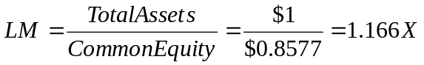

And, since the 2006 ROA is equal to 13.33% and the 2006 NPM is equal to 10.60%, and we know that ROA = NPM x TAT, we can calculate the TAT as follows:

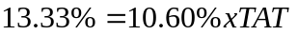

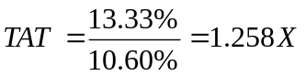

We can now use the Du Pont Analysis to compare Cox Oil Company, Inc. to the industry average, which looks like this:

ROE
Cox S&P
2006 2006
13.52% 27.24%

ROA x LM
Cox S&P Cox S&P
2006 2006 2006 2006
6.41% 13.33% 2.109X 1.166X

NPM x TAT
Cox S&P Cox S&P
2006 2006 2006 2006
5.59% 10.60% 1.148X 1.258X

So, now what can we say about Cox Oil Company, Inc. in comparison with the industry???

